Data Sources of GTED Data:

Note: in this file, you will find both how GTED explains the data source and the location of files that their description mentions. If GTED only attached the document of a specific year, I have also downloaded all documents of the same name that are available on internet.

**Albania:**

Shpenzimet Tatimore, Ministria e Financave dhe Ekonomisë

Ministry of Finance Tax Expenditure Report <https://financa.gov.al/shpenzimet-tatimore-2/>

It’s a yearly report. Documents between 2018 and 2020 are available on the website, but GTED said they found the documents between 2015 to 2021. Tried to google previous years’ documents but did not find anything.

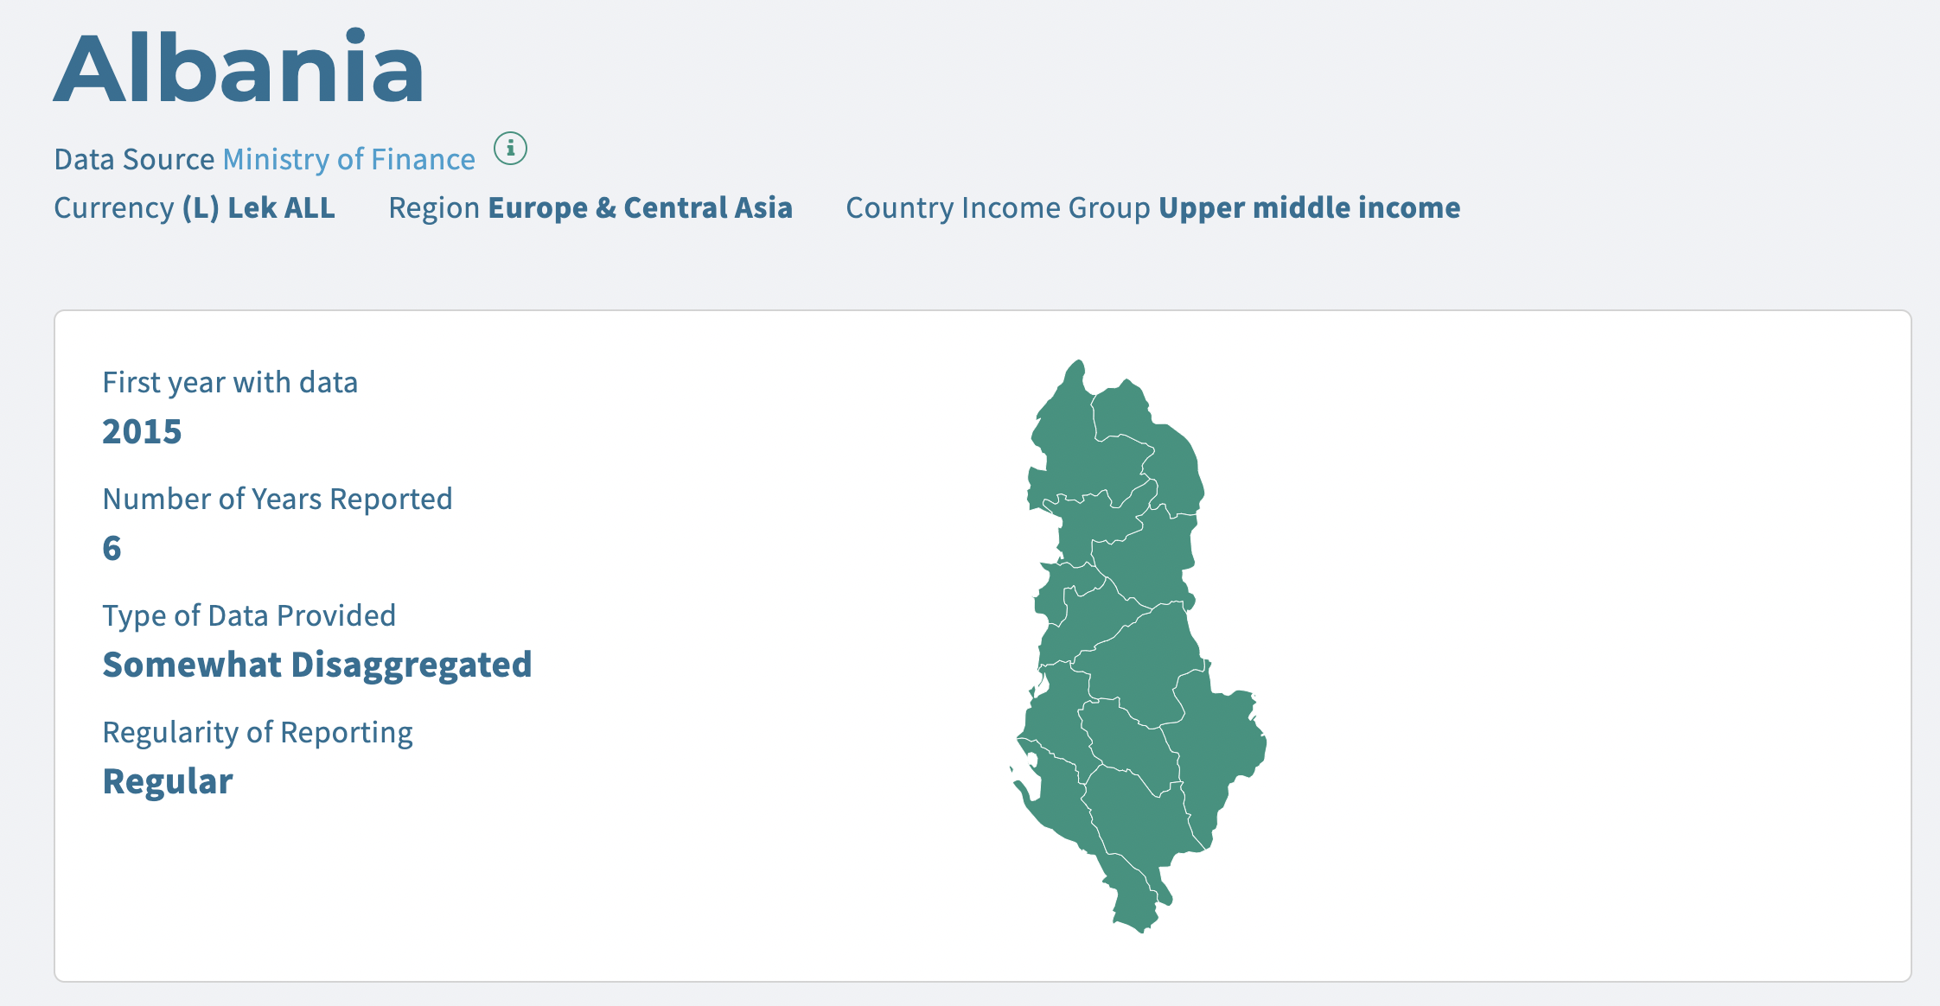

**Ecuador**

Manual de Gasto Tributario 2008-2020, Servicio de Rentas Internas

Internal Revenue Service, Tax Expanditure Manual 2008-2020

<https://www.sri.gob.ec/web/intersri/estudios-investigaciones-e-indicadores>

It’s a yearly report released every year between 2008 and 2020. No document for 2009.

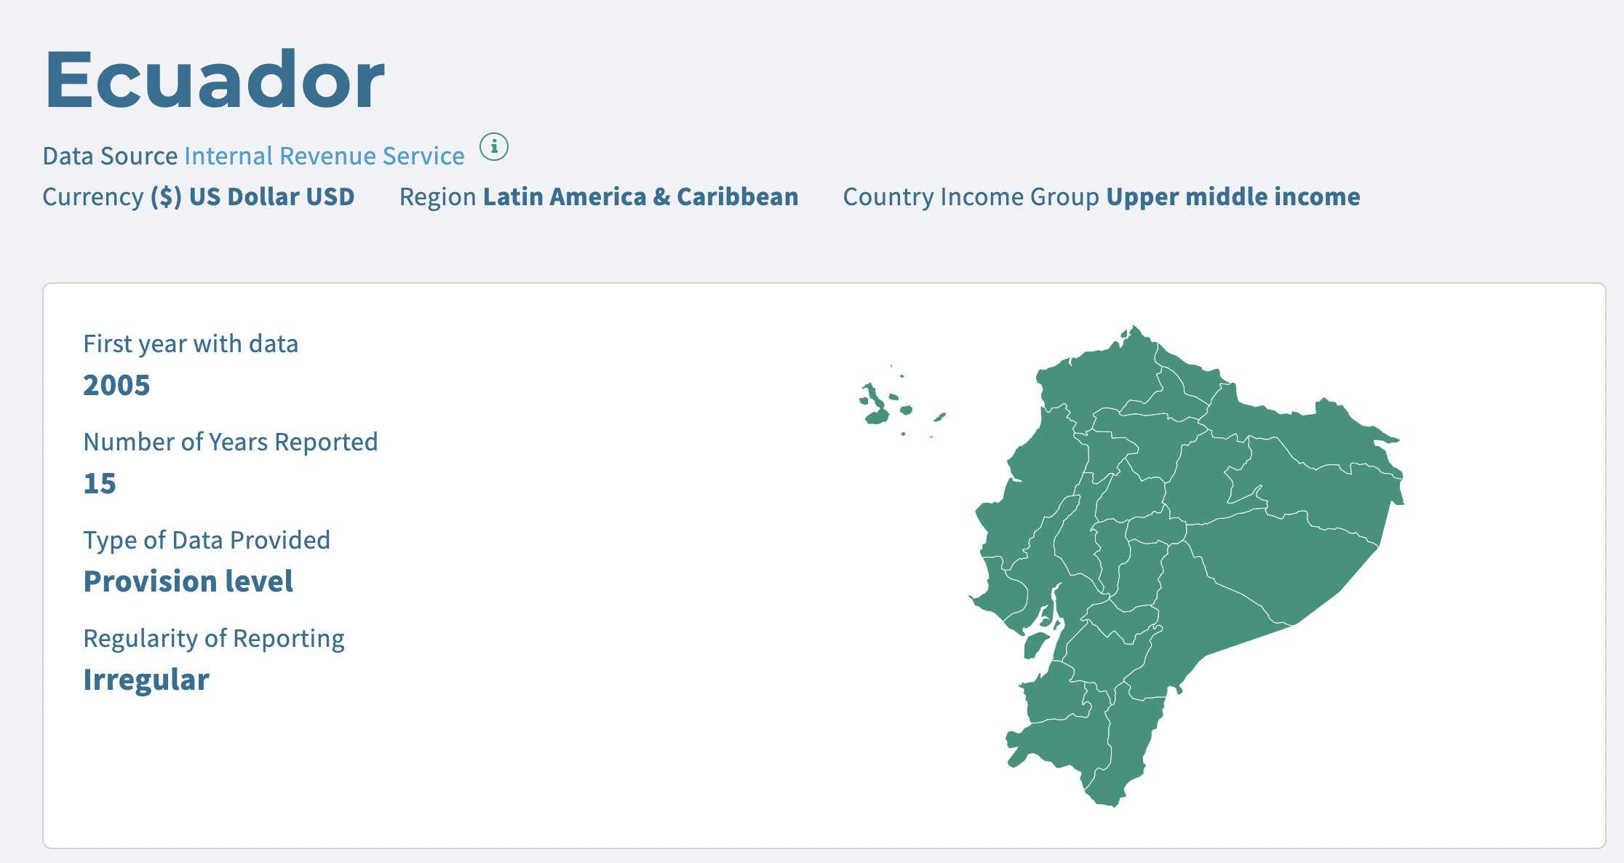

**Eswatini**

Eswatini Revenue Authority Integrated Revenue Report

<https://www.ers.org.sz/publications/annualreports.php>

The reports are available since 2011, but only 2021, 2020, 2018, 2017 reported tax revenue foregone.

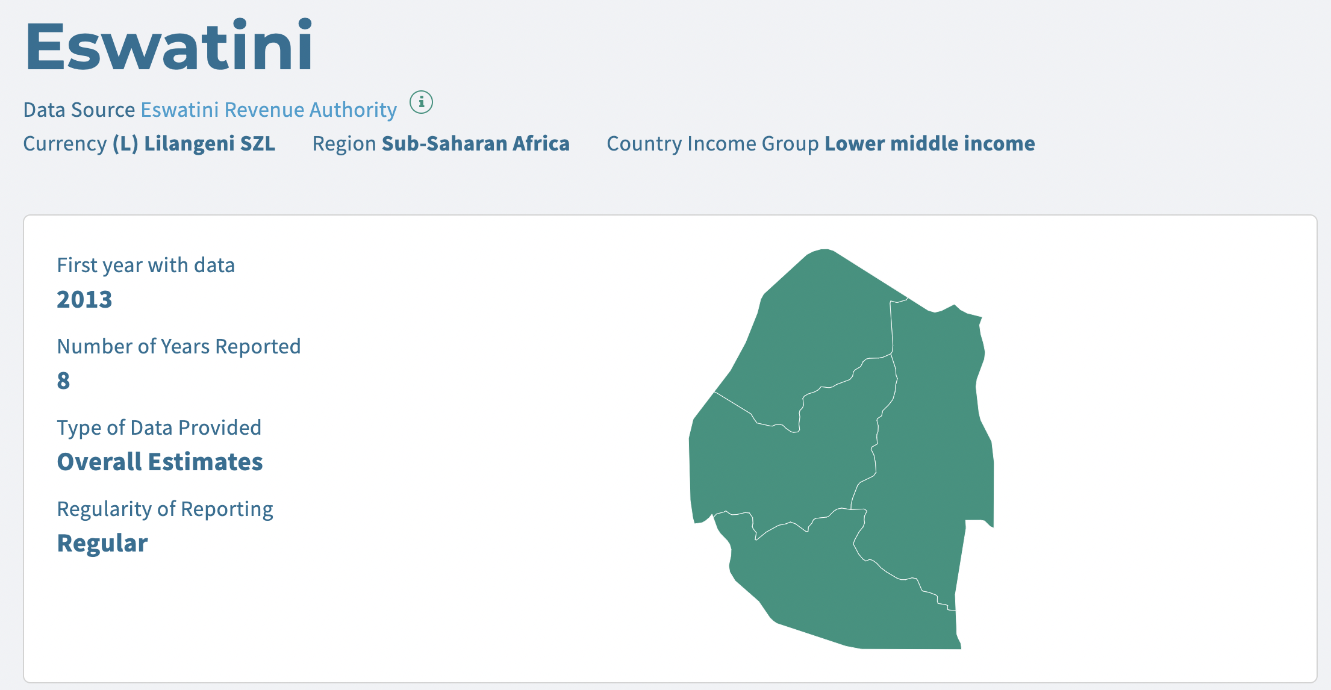

**Guatemala**

ESTIMACIÓN DEL GASTO TRIBUTARIO De los principales impuestos administrados por la SAT

Tax administration released a yearly dataset of the Estimation of Tax Expenditure of the Main Taxes Administered by the SAT from 2009 to 2021

<https://portal.sat.gob.gt/portal/analisis-estudios-tributarios/#1506976607233-cfdb5baf-4926>

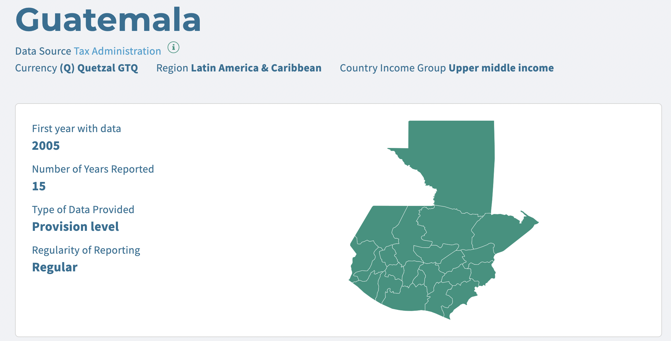

**Honduras**

Ministry of Finance

Proyecto de Presupuesto General de Ingresos y Egresos de la República Ejercicio Fiscal

Only found the report of 2022 and 2021.

Besides the documents showed by GTED, I also found a portal of similar document here <https://www.tsc.gob.hn/biblioteca/index.php/component/tags/tag/presupuesto-gral>

However, for some reasons, I couldn’t download the documents from this portal. Thus, there should be data since 2006 but GTED didn’t record any data since 2017.

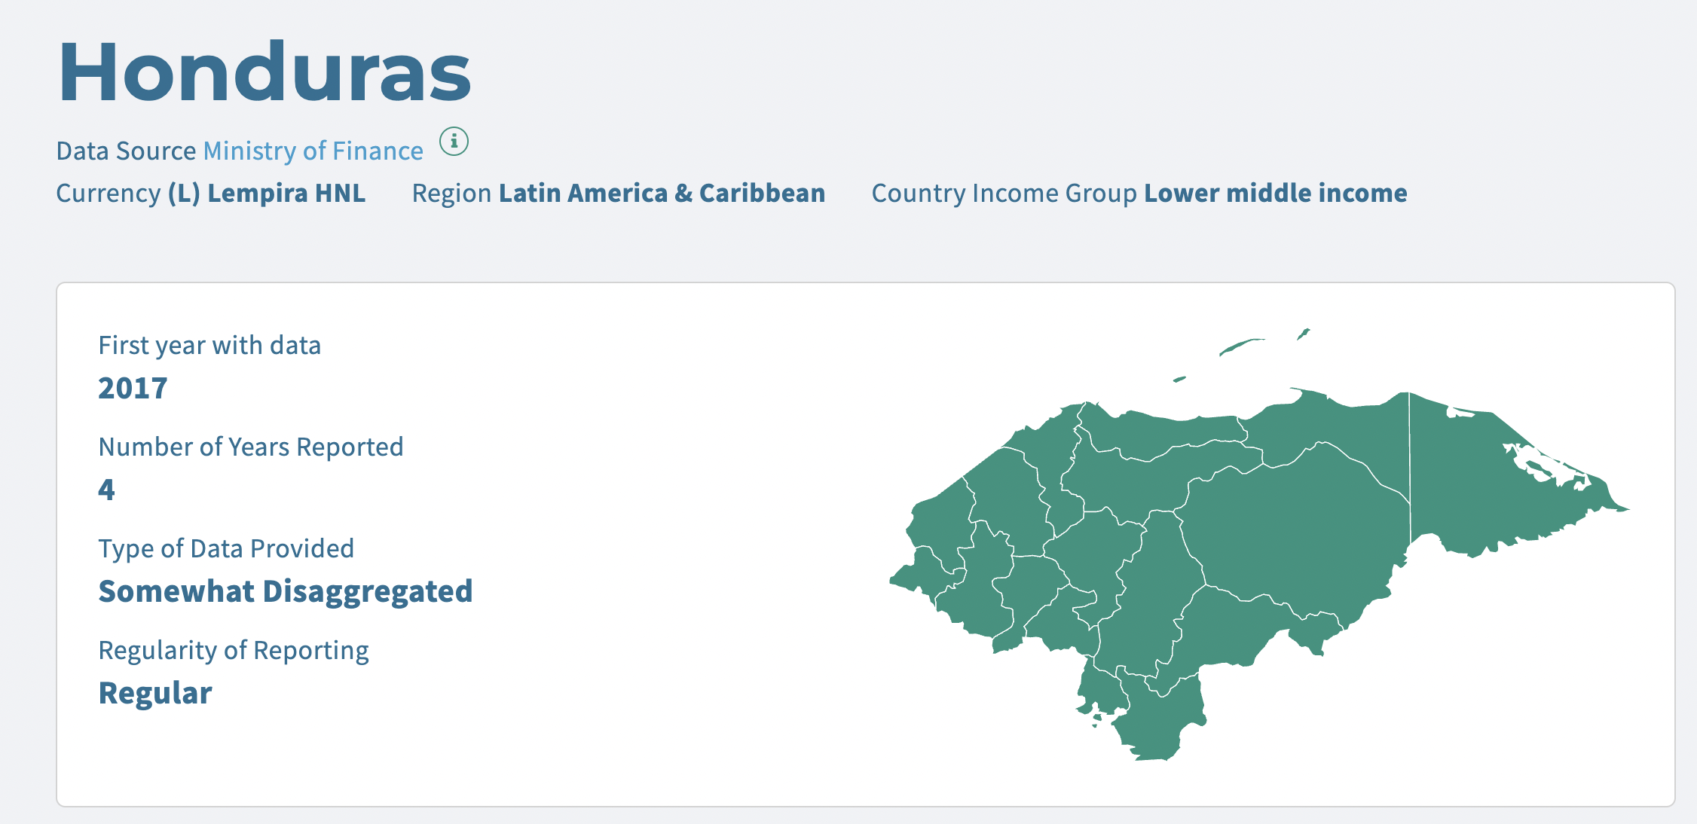

**Rwanda**

Ministry of Finance and Economic Planning Tax Expenditure Report

<https://www.taxdev.org/sites/default/files/2021-06/Rwanda_tax_expenditure_report_FY1920.pdf>

Rwanda has only begun reporting TE in 2018. There are 3 reports available now, namely 2018/2019, 2019/2020, 2020/2021. The first one 2017/2018 seems not available for public.

The report was collaboratively produced with TaxDev and published by Rwanda's Ministry of Finance and Economic Planning. <https://www.taxdev.org/search?search_api_fulltext=tax+expenditure+Rwanda>+

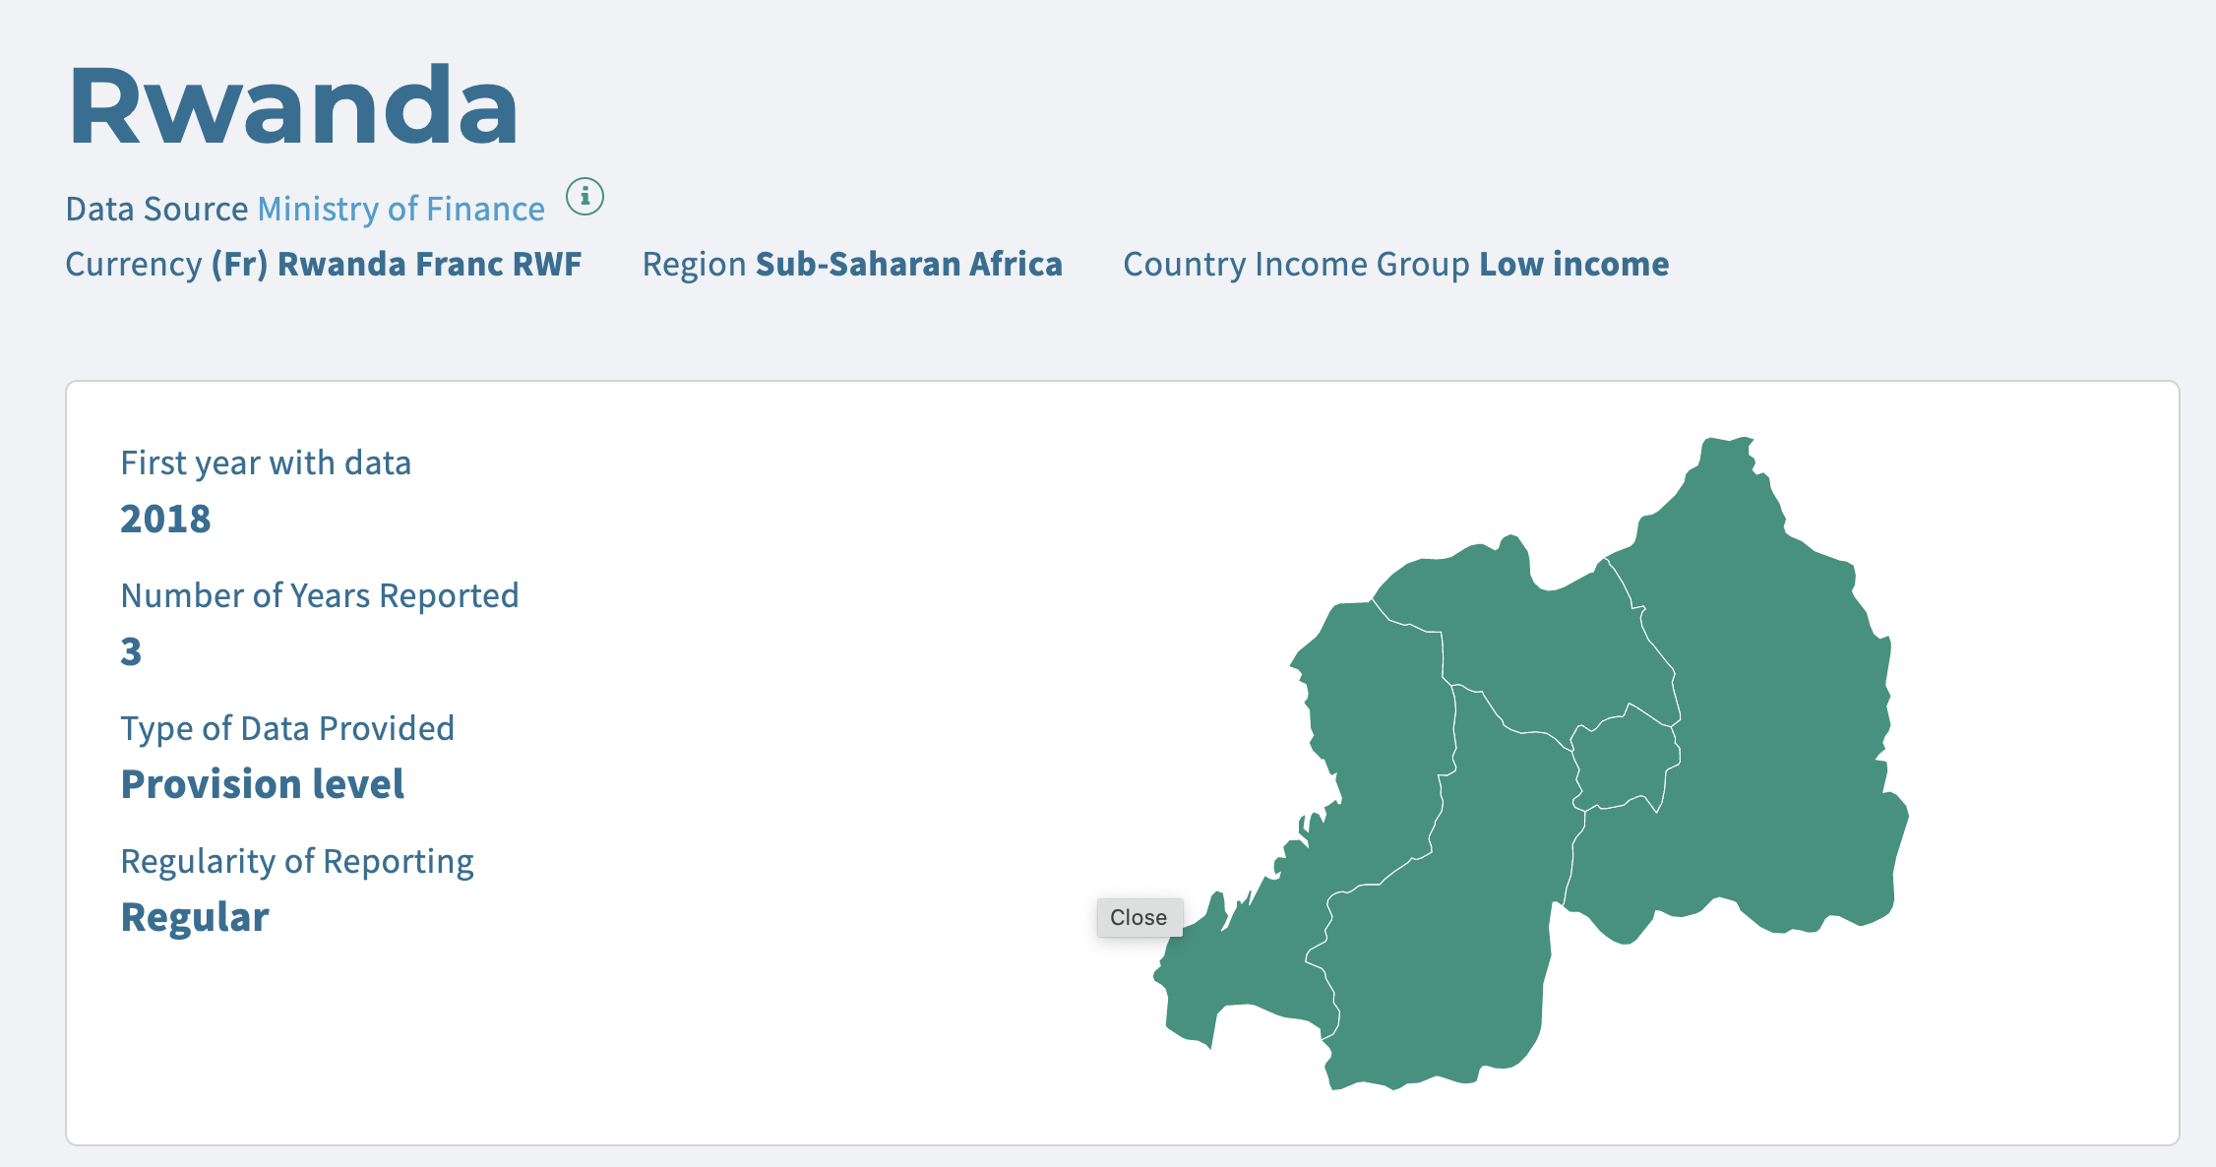

**Senegal**

MINISTERE DES FINANCES ET DU BUDGET Rapport d’évaluation budgétaire des dépenses fiscales

Ministry of Finance and Budget Report on the budgetary evaluation of tax expenditures

GTED only showed the report of 2019, but I found the same report from 2015-2020.

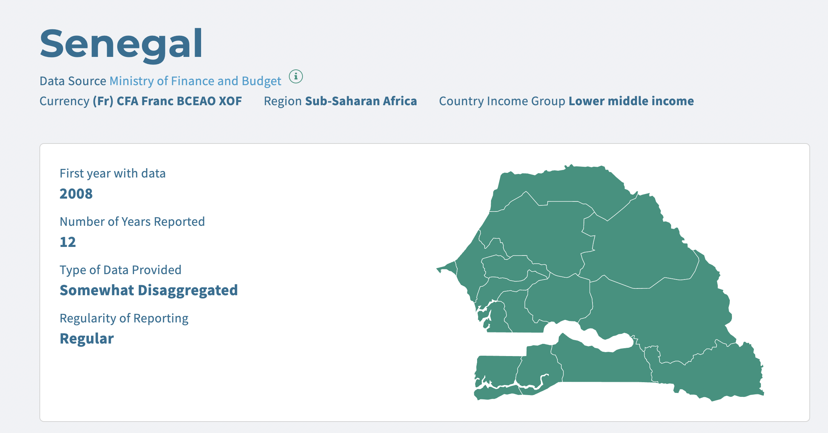

**Uganda**

Ministry of Finance, Planning and Economic Development, Tax Policy Department

Tax Expenditure Report

GTED only showed one report on 2019/20, but I found 3 annual reports between 2020-2022.

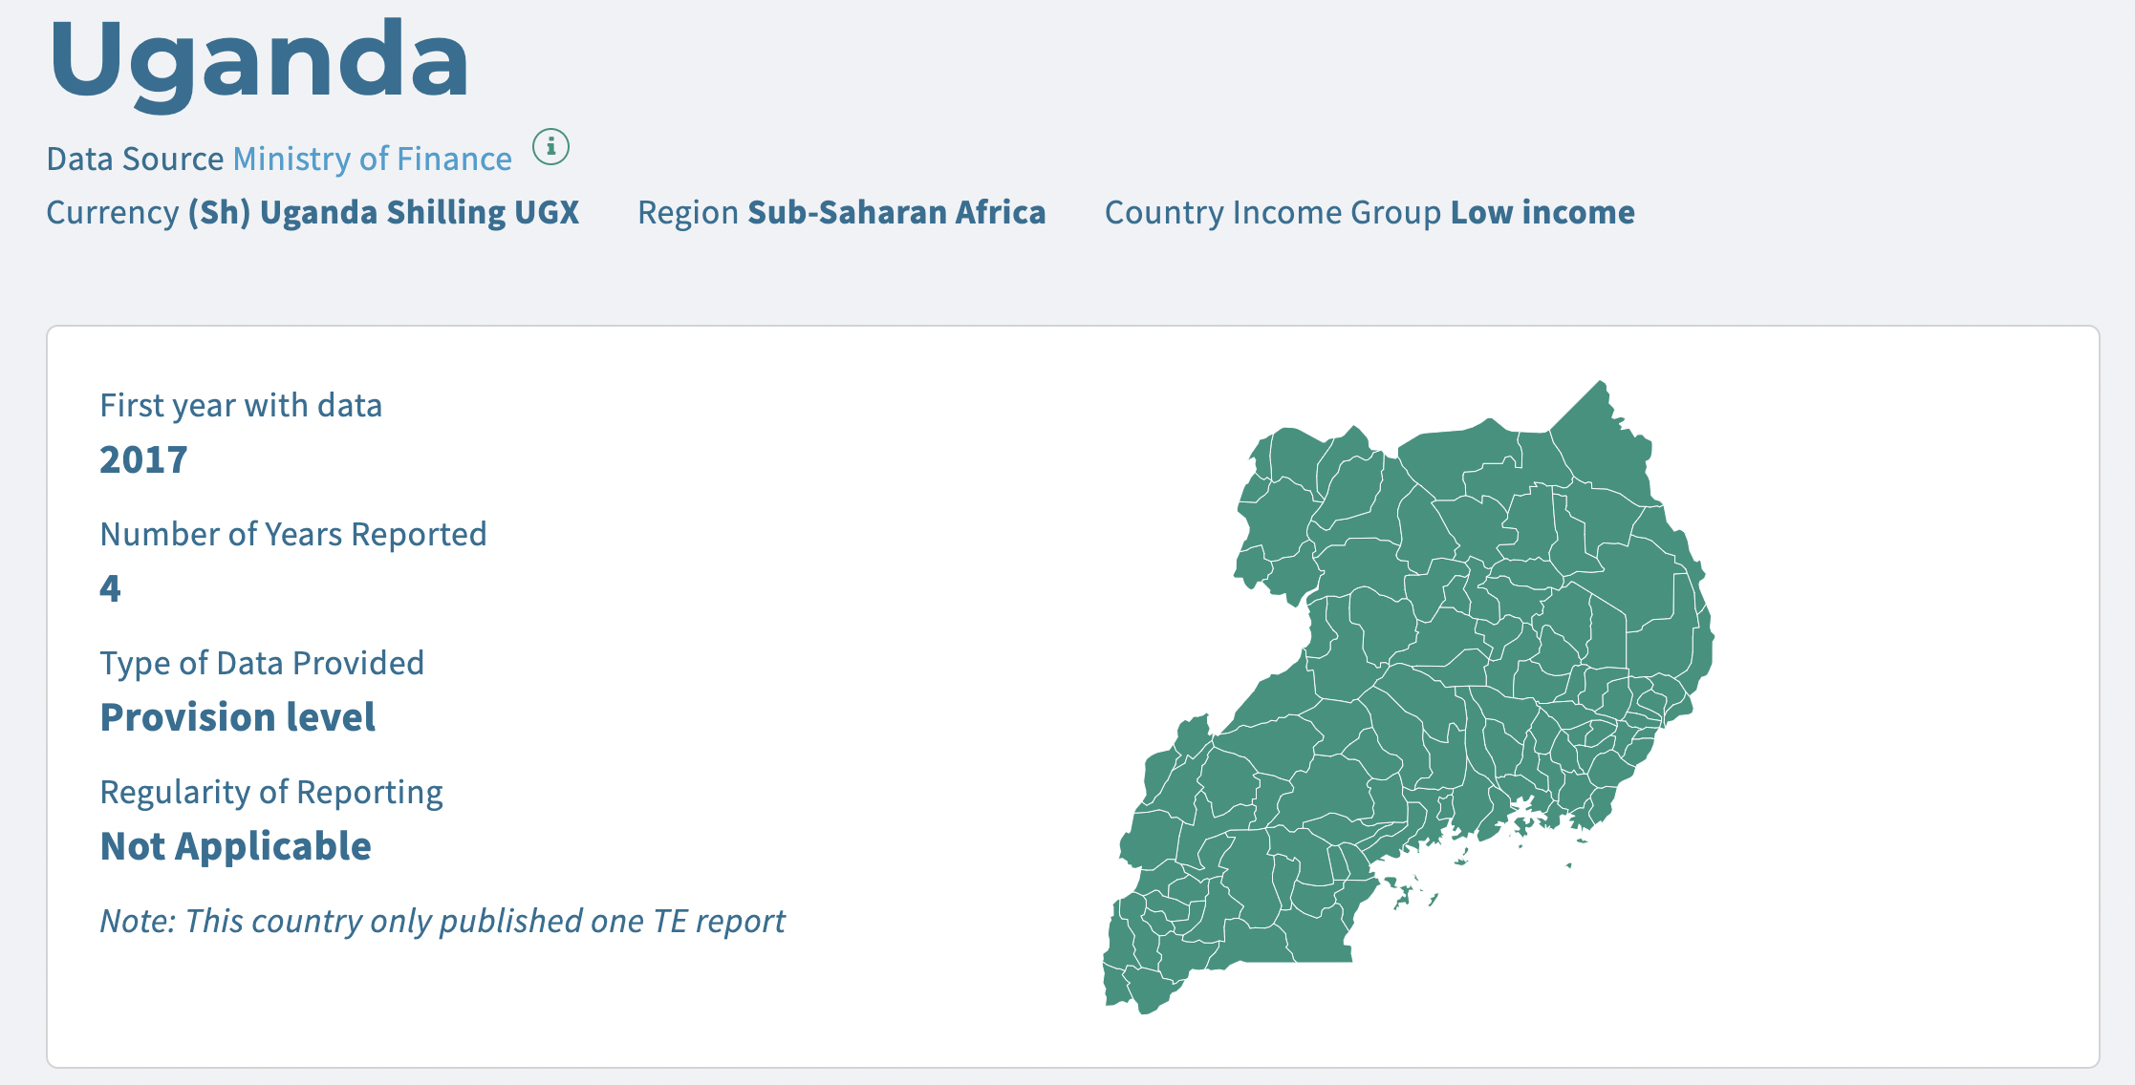

**Countries that GTED did not specify data sources:**

**Costa Rica**

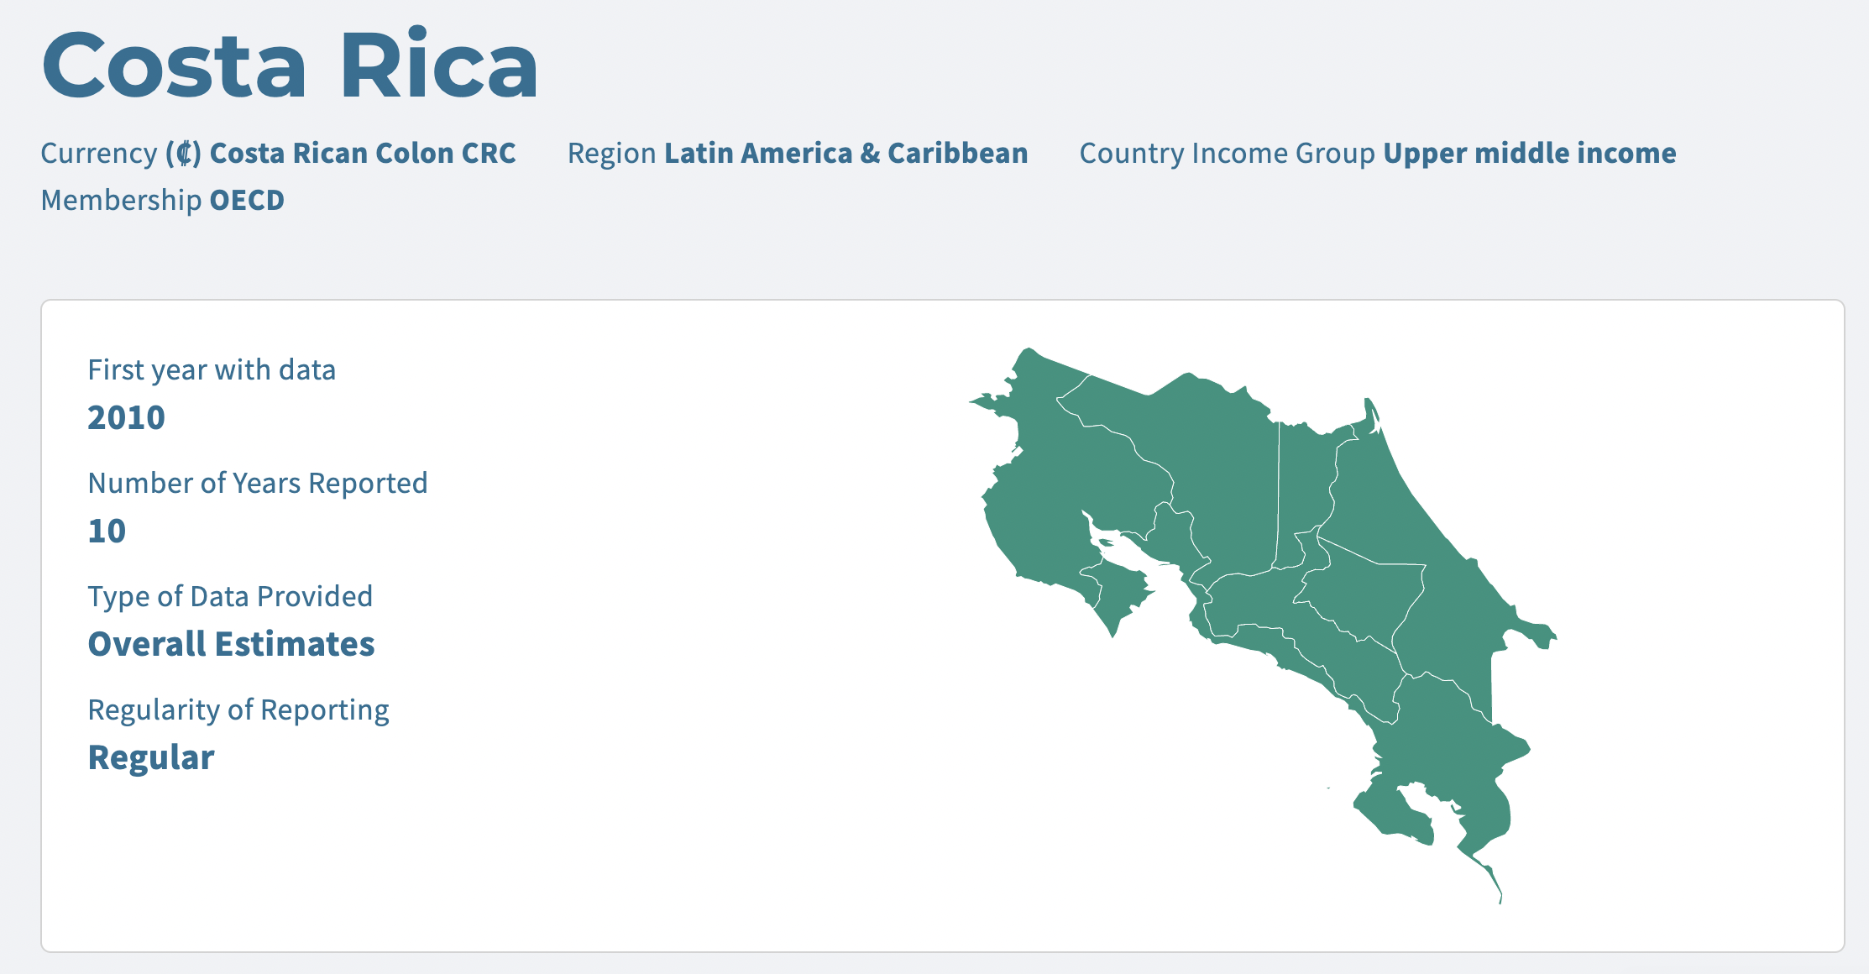

**Dominican Republic**

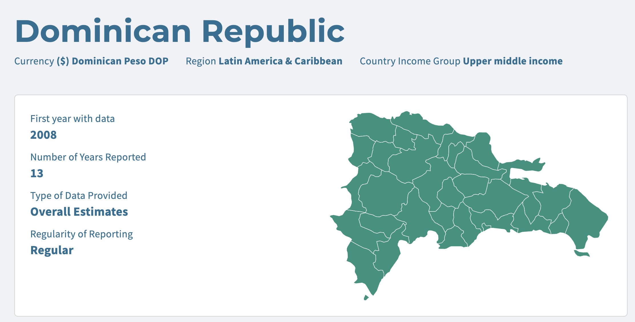

**Ethiopia**

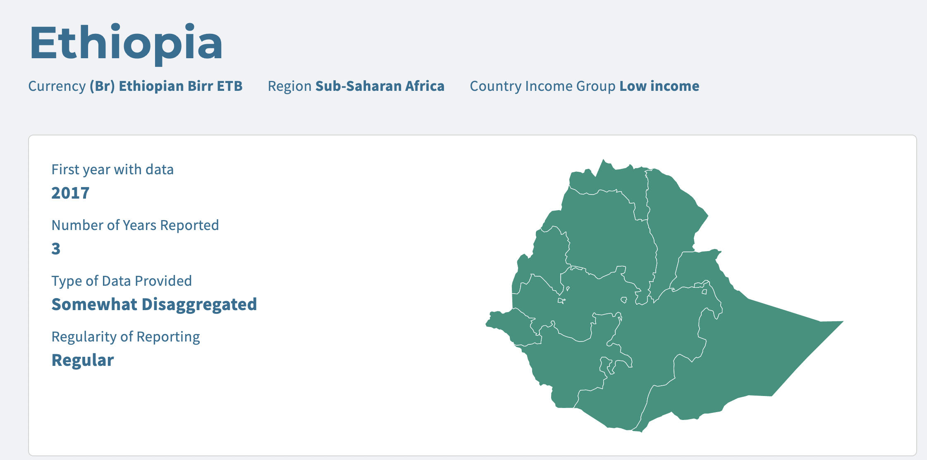

**Mexico**

